December 4, 2022

Stockmans Hollow HOA
The Stockmans Hollow Homeowners Association Board of Directors would like to inform you of a few issues pertinent to our neighborhood and Homeowners Association.

2024 Dues
    - The HOA Board has approved and set the 2024 dues to be at $140 per year, consistent with the reduced dues and held fixed for the five years (2020 – 2024).
    - The deadline for payment of your 2024 HOA dues is January 15th.
    - There are two options available for payment of dues:
- To pay by check – please mail a check in the amount of $140 made out to Stockmans Hollow HOA, and addressed to PO Box 461024, as shown at the address at the top of this page.
- To pay by credit or debit card – you can access a payment portal via the website
https://stockmanshollow.com/pay-dues. Please note that there is a $5.39 convenience fee collected by STRIPE for processing the online payment.
    - HOA membership and dues are mandatory for all houses in Stockmans Hollow. Your membership dues fund the maintenance of our neighborhood common areas and silt basins, including lawn care, trees, and landscaping. The HOA is also responsible for upkeep of the neighborhood entry sign and certain fencing along common areas as defined in our neighborhood covenants.

Annual Meeting
The annual meeting will be held at the Sump Memorial Library on January 8th, 2024 at 6:00 pm.
This meeting is open to all members of the Stockmans Hollow Homeowners Association. At the meeting, we will vote to ratify the 2024 budget as well as allow for the election of two member to the board of directors.
SCAN THE QR CODE TO JOIN US ON FACEBOOK!!!

TO BE COMPLETED BY HOMEOWNERS:
- Please fill out the ballot and either mail it to Stockmans Hollow HOA, PO Box 461024 Papillion, NE 68046, or scan and e-mail it to info@stockmanshollow.com.

Budget Ratification (as presented in the following pages)
For ratification of the enclosed budget. Vote for ONE by placing an X in the box to the left:

YES, I vote to ratify the enclosed budget for 2024

NO, I vote not to ratify the enclosed budget for 2024

Annual Meeting Proxy Ballot (for further information, refer to the following page)

To be a member of the HOA Board of Directors or to elect a neighbor, two Write-In vote is allowed:
Write-in: (name, property address, phone, email)

First Write-in Name: _______________________________________________________________
Second Write-in Name: _____________________________________________________________

Please fill out the ballot, including your name, address, and signature above. Completed ballots can be mailed to Stockmans Hollow HOA, PO Box 461024 Papillion, NE 68046, or scanned and e-mailed to info@stockmanshollow.com.

Name: ____________________________________________
Address: __________________________________________
Signature: _________________________________________

HOA Board Election
You will find a proxy ballot for the HOA Board Election on the previous page. We have two open write-in positions. Board members receive financial updates each month via email and have a responsibility to assist in voicing an opinion on HOA issues as they arise. Six board meetings are scheduled during the year and there is an expectation that all members attend at least 50% of the meetings.

Budget
    - The HOA Board of Directors has adopted the enclosed budget, which will be discussed and voted on at the Annual Meeting. Please review it and let us know if you have any questions.

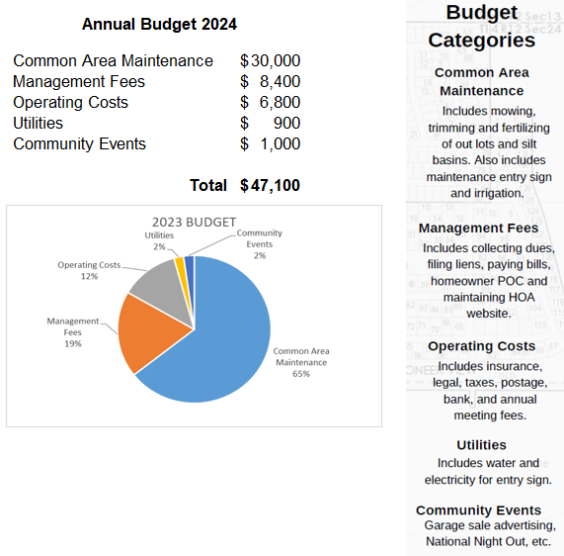

Projected 2023 Operating Results

Favorable increase to reserves of $2,599 is projected (with dues set at $140/homeowner)

